
Software Solution Architecture Document

Contents
Introduction 3
System Overview 4
Architecture Design 5
The Presentation Layer 5
Log in page: 7
Model-View-Controller (MVC) Pattern 7
Model: 7
View: 7
Controller: 8
DataAccessLayer 9
ApplicationDBContext: 9
DbInitializer.cs: 9
Repositories: 10
UnitOfWork: 10
Database Migrations: 10
Advantages of repository design pattern 11
Separation of Concerns: 11
Code Reusability: 11
Testability: 11
CommonHelper 11
EmailSender 11
Utility: 11
Additional Application Details 11
Dependency Injection: 11
Authorization and Authentication: 11
Configuration Settings: 12
Microsoft SQL Server 2019: 12
Security 12
Role-Based Authentication: 12
Google reCAPTCHA: 12
SSL (Secure Sockets Layer): 12
Key Components: 13
Registration & Log in 13
Manage Listing(create, read, update & delete) 13
Advertise listing 13
Search listing 13
Shorlist listings 13
Messaging 13
Manage account settings 13
Subscribe to a plan 13
Payment gateway integration 13
SMS Integration through Twilio 13
CMS for guidelines, articles & FAQs & about us 13
Error Handling and Logging: 13
Integration with Payment Gateway 13
Deployment Architecture: 13
Conclusion 14

Introduction
The purpose of this document is to provide a detailed overview of the software solution architecture for the "Sharehouse.pk" web application. This document explains the architecture design, component organization, and the flow of user interactions within the application. The "Sharehouse.pk" application is developed using Microsoft ASP.NET Core 6 & Microsoft SQL Server 2019 and follows the Model-View-Controller (MVC) architectural pattern. The solution consists of four projects, namely DataAccessLayer, Models, CommonHelper, and the Sharehouse.pk – an asp.net core 6 web application.

System Overview
The "Sharehouse.pk" web application aims to provide a platform for users to interact with a shared housing marketplace. The application is designed to facilitate the seamless sharing of property and person listings, allowing users to search, view, and post housing/personal listings. The application is built using Microsoft ASP.NET Core 6, leveraging the MVC architectural pattern for efficient separation of concerns. Microsoft SQL Server 2019 has been used on the backend as database management system. The sharehouse.pk is an asp.net core web application that contains views and controllers. Views contains html templates used to render templates based on model passed. Controller contain action method that are invoked by user interaction. All model classes have been added in a separate class library project which serve as the business logic layer for the application. Database operations are done through a separate class library project named ‘DataAccessLayer’ and reference of this project is added in Sharehouse.pk web application. CommonHelper library project contains classes to implement common functions like sending email, creating/deleting file, sending SMS etc.

Architecture Design
The solution architecture is structured to ensure maintainability, scalability, and separation of concerns.
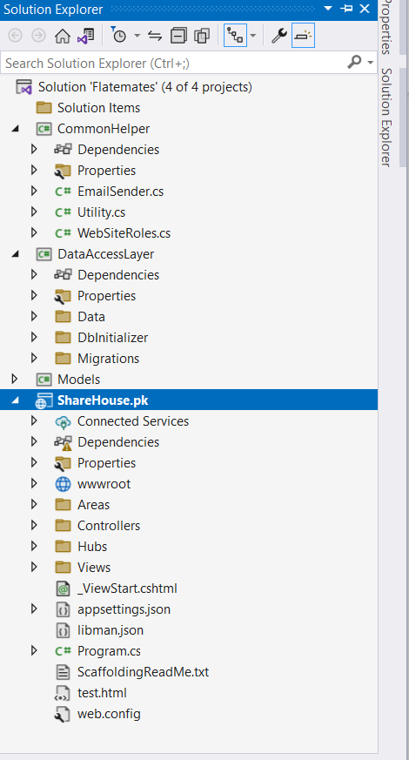

The Presentation Layer
The presentation layer is implemented using the Sharehouse.pk web application project. This project contains views and controllers responsible for handling user requests and rendering the appropriate responses. Users interact with the application by requesting pages through their web browsers.
Home page
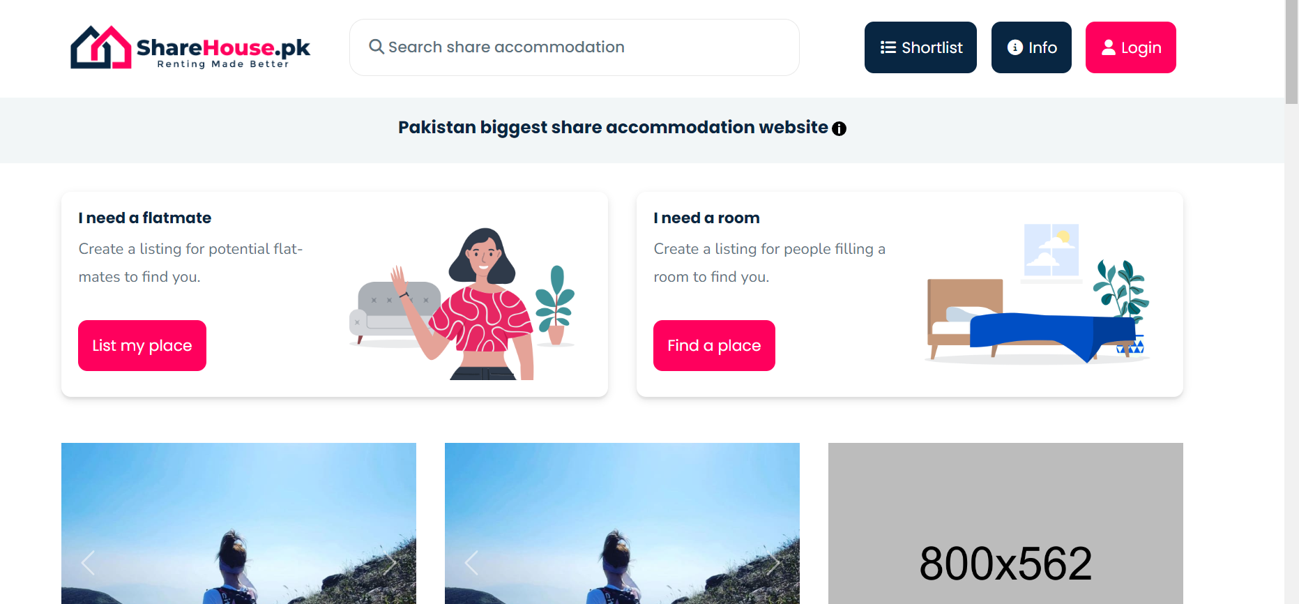

Log in page:
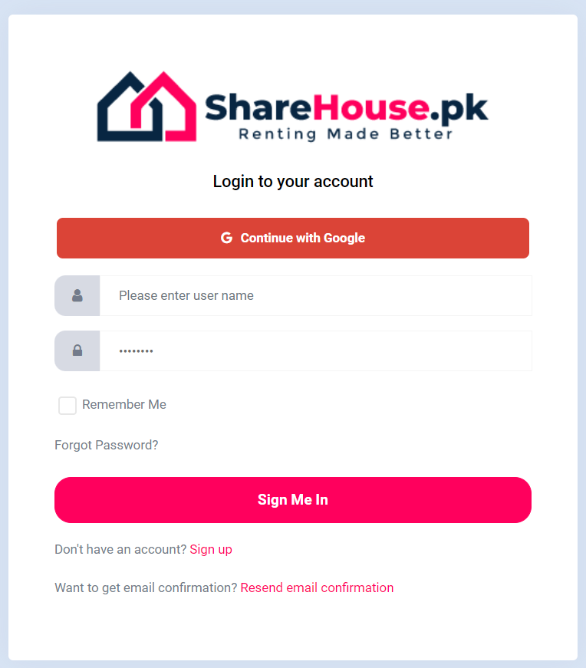

Model-View-Controller (MVC) Pattern
The MVC architectural pattern is utilized for the development of the Sharehouse.pk web application. This pattern divides the application into three core components:
Model: The Models project contains all the model classes, which represent the database entities. Each model class is associated with a database table and includes attributes that map to the corresponding table fields. The model classes define the structure and behavior of the data used within the application.
View: Views are responsible for presenting data to the user. They are HTML templates combined with embedded code that retrieves and formats data from the associated model. In the Sharehouse.pk application, views are located within the web application project and are rendered by the controllers.
Controller: Controllers handle user requests, perform necessary business logic operations, and coordinate the interaction between models and views. The controllers receive requests from users, retrieve data from the models, apply business logic, and pass the resulting model to the appropriate view for rendering. Controllers are located within the web application project.
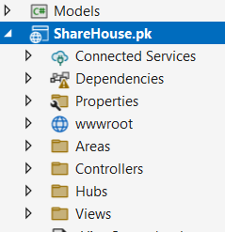
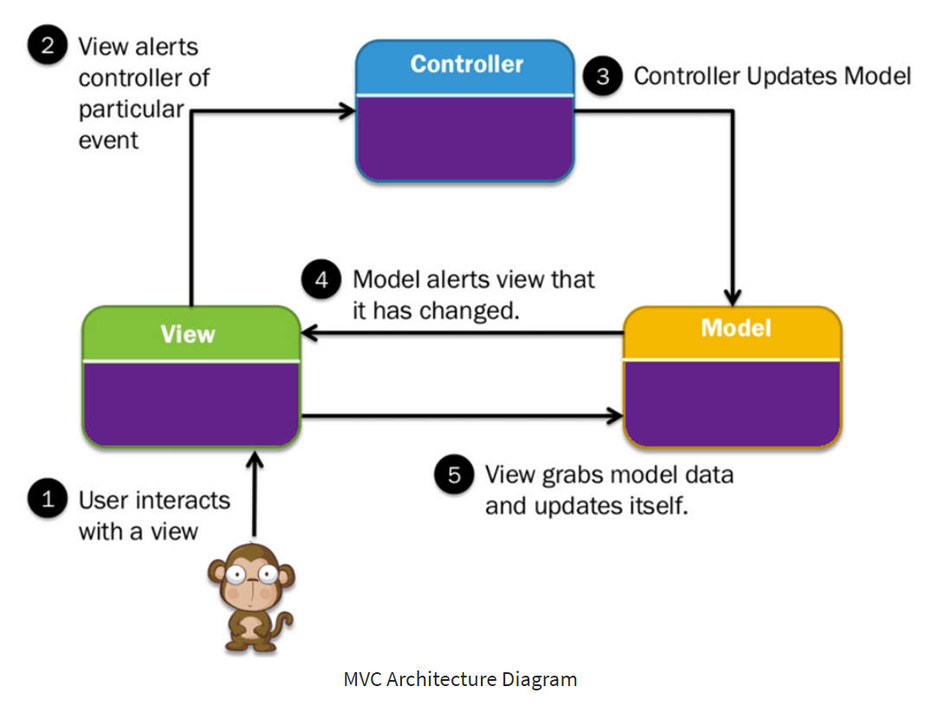

DataAccessLayer
The DataAccessLayer project is a class library project that focuses on managing data access operations. It follows the repository design pattern, which provides a centralized and consistent approach to interact with the underlying database.
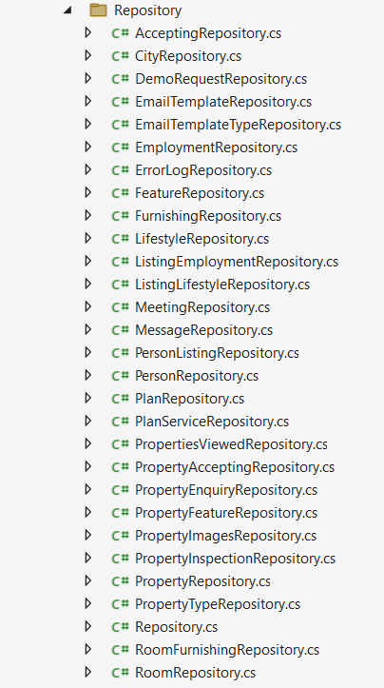

ApplicationDBContext: This class, inherited from IdentityDbContext, serves as the application's database context. It provides access to the underlying database and defines the structure of the identity-related tables. The context class also overrides the OnModelCreating method to configure custom table names for the identity tables.
DbInitializer.cs: This class is responsible for database initialization and data seeding. On the first run of the application, it creates an admin user and sets up user roles. The DbInitializer class ensures that the necessary data is available in the database to support the application's functionality.
Repositories: For each model class in the Models project, there is a corresponding repository class in the DataAccessLayer. These repositories encapsulate data access operations specific to each model. The main repository class contains common functions used across multiple model repositories.
UnitOfWork: The UnitOfWork class, inherited from the IUnitOfWork interface, provides a single-entry point for managing multiple repositories. It instantiates an object of each repository class and exposes methods to access them. The UnitOfWork class also includes a save method, which commits any changes made within the repositories to the database.
Database Migrations: The DataAccessLayer project includes database migration functionality, allowing for smooth schema changes and version control of the database structure. Migrations are used to keep the database schema in sync with the application's models.
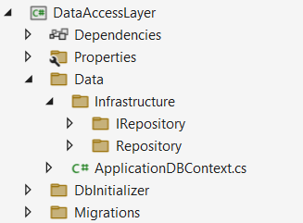

Advantages of repository design pattern
Separation of Concerns: The repository pattern separates the data access logic from the business logic and presentation layers. This separation allows for independent development, testing, and maintenance of each layer.

Code Reusability:
By encapsulating data access operations within the repository classes, these operations can be reused across different parts of the application. This reduces code redundancy and promotes code maintainability.

Testability:
The repository pattern facilitates unit testing by allowing the business logic to be tested independently of the data access layer. Mock repositories can be used during testing to isolate the business logic from the actual database.

CommonHelper
The CommonHelper project consists of utility classes that provide common functionality used throughout the application. It includes the following components:
EmailSender: This class handles email sending functionality within the application. Other parts of the solution can reference this class to send emails when needed.
Utility: The Utility class contains various common utility functions required by the application. These functions include saving files to the physical drive, reading file streams, deleting files, sending SMS messages, and reading configuration settings. The Utility class promotes code reuse and encapsulates commonly used operations.

Additional Application Details
The Sharehouse.pk web application project references the DataAccessLayer, Models, and CommonHelper class library projects. The following additional details are worth noting:
Dependency Injection: In the program.cs file of the Sharehouse.pk web application, all the required dependencies are registered and injected using ASP.NET Core's built-in dependency injection framework.
Authorization and Authentication: The web application utilizes authentication and authorization mechanisms provided by ASP.NET Core. This ensures that only authenticated users with appropriate roles can access certain features or perform specific actions within the application.

Configuration Settings: The application's configuration settings, including the database connection string, SMTP settings for email sending, and other application-specific settings, are defined in the appsettings.json file. This separation of configuration from the codebase enables easier configuration management.
Microsoft SQL Server 2019: The Sharehouse.pk application utilizes Microsoft SQL Server 2019 as the backend database management system. SQL Server provides robust data storage capabilities and seamless integration with the ASP.NET Core framework.

Security
The application incorporates robust security measures to protect user data and ensure a secure environment. It implements role-based authentication and authorization, allowing access control based on user roles. Additionally, it integrates Google reCAPTCHA to prevent unauthorized form submissions and ensures SSL (Secure Sockets Layer) is used on the hosting server, encrypting data transmissions to safeguard against potential security threats. These measures collectively enhance the overall security posture of the application, mitigating risks and protecting sensitive information.
Role-Based Authentication: Role-based authentication and authorization is implemented to control user access and permissions within the application. Different roles, such as admin and regular users, have distinct privileges and restrictions based on their assigned roles.
Google reCAPTCHA: The public website of Sharehouse.pk incorporates Google reCAPTCHA to ensure that only valid human users can submit data through forms. This adds an extra layer of security and helps prevent automated or malicious form submissions.
SSL (Secure Sockets Layer): Sharehouse.pk secures its domain using SSL, which encrypts the communication between the user's browser and the web server. SSL provides a secure and trusted connection, safeguarding sensitive user information during data transmission.

Key Components:

Registration & Log in

Manage Listing(create, read, update & delete)

Advertise listing

Search listing

Shorlist listings

Messaging

Manage account settings

Subscribe to a plan

Payment gateway integration

SMS Integration through Twilio

CMS for guidelines, articles & FAQs & about us

Error Handling and Logging:
Proper error handling and logging has been implemented in the application.

Integration with Payment Gateway
The sharehouse.pk will integrates a payment gateway for secure and seamless plan subscription payments. To prioritize data security, sensitive payment information is not stored within the application's database. Instead, the application redirects users to a trusted payment gateway's secure payment page, ensuring that all payment details are handled directly by the payment gateway. The application establishes a secure communication channel using encryption protocols during the redirection process. It follows best practices by tokenizing or using unique identifiers provided by the payment gateway to associate payments with user accounts, eliminating the need to store sensitive data locally. Once the payment is processed, the application receives a response from the payment gateway, allowing for updates to the user's subscription status or any necessary actions based on the transaction result. This approach maintains a high level of security and safeguards sensitive payment information throughout the payment process.

Deployment Architecture:
The deployment architecture for the application involves hosting it on a service with the latest version of Internet Information Services (IIS) as the web server and SQL Server as the database management system. The application is published using Microsoft Visual Studio, which generates the necessary files and configurations. The deployment package is then uploaded to the hosting service, and the application is configured to run on IIS. The hosting service provides a secure and monitored environment for the application to operate effectively, ensuring reliable hosting and seamless data management.

Conclusion
The "Sharehouse.pk" software solution architecture follows best practices for creating a scalable, maintainable, and modular web application. The adoption of the MVC architectural pattern, repository design pattern, and the separation of concerns ensure a well-structured and extensible codebase. The use of class library projects, such as DataAccessLayer and CommonHelper, further promotes code reuse and modular development. The application leverages ASP.NET Core's features and frameworks to provide a secure, user-friendly, and efficient shared housing marketplace platform.

